HOSA Boosters Agenda

Tuesday, October 11, 2022 at 6:30pm at MMACHS

Call to order 6:38pm

1. Attendance

Board Attendance: Brook Heath, Gary VanAckern via Zoom, Kelley Curtis, Mary Swanke, Malissa McCulloch, Adam Greyson via Zoom, Garry Heath

Advisors: Blake Gaudet

Students: Ashlynn Heath, Roy Tong, Sophie Curtis, Emily Davis

Visitors: Connie Davis, Tami Jo VanAckern

1. Approval of previous meeting minutes – unanimously approved
2. Treasury report – 32,302.50 + $585 – $25 = $32,862. Check to Vern for cooking potatoes would not process. Gary V. paid $55 in cash. (This is reflected in the current balance). Potato deposits were $22,776
3. Unfinished business
   1. Outreach subcommittee – Kelley and Dawnetta refined the anatomage table proposal. St. Luke’s foundation budget cut by $350K this year. They are willing to donate 5-10K if matched. Blue Cross was asked. Micron Foundation said no. Dr. Pate will help Kelley with approaching ICOM.
   2. Potato Fundraiser – Lessons learned:

* Next year go online 100%. Add student name drop down menu on website. Sort by customer name. Stats of student sales on the website so people can support those who need more bags sold. Charge sales tax, but not the processing fee.
* NO late orders, have a FINAL date and stick to it. (They can still donate $).
* The lack of gold potatoes was a problem. Also, we had quality issues and had to refund 9 bags that had rotten potatoes. Pursue another potato source for next year, Gary will work on this.
* Consider 25 lb rather than 50 lb. Order 10% more than needed. Sell potatoes to corporate sponsors (CapEd).
* Provide students with a social media kit to promote the website rather than the current packets.
* Student stats posted in the student center to encourage friendly competition and higher sales

Approximate $12,177 profit

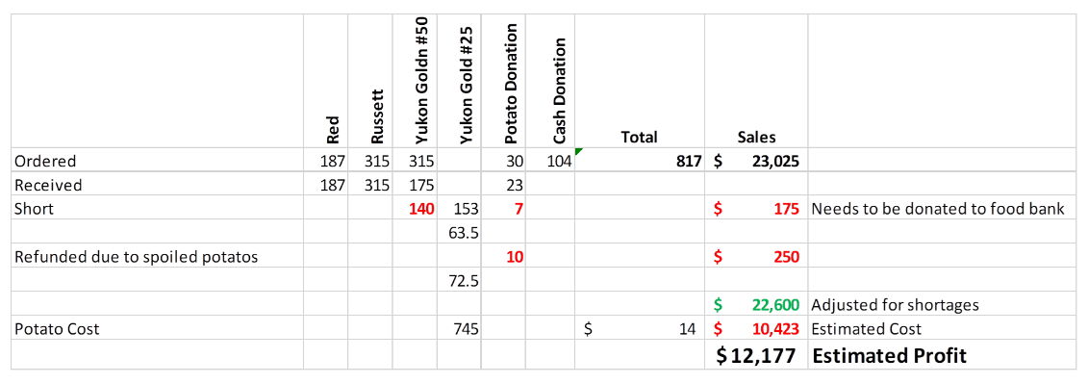

* 1. Haunted House (Oct. 22) – Facebook 70 currently interested. Booster responsibilities include Social Center decorations, help with stations, and check in. Connie D. and Brook can help Malissa. Fog machine with red lights (belongs to Malissa). PVC photo booth frame (Malissa will build. Gary will donate PVC pipe). She will also purchase balloons. Seven stations will be set up. Budget of $150 unanimously approved. Kids set up 12:30-6:30pm on Friday. We will also purchase candy and cupcakes (ask parents via Signup Genius – Brook). Adam will print a poster for each station. Malissa will get that info to Adam. Also, an all-weather banner that says, “MMACHS Haunted Hospital this Saturday.” These can be used again in the future. Sign up Genius will go out to parents for cupcakes (20 dozen), candy (150 piece x 15 bags), and water to be delivered Friday or Saturday.
  2. Curriculum review – no new updates at this time
  3. Jacket embroidery – Brook will update us at the next meeting

1. New Business
   1. Community Partner Appreciation Breakfast, students in HOSA Pro

Boosters verbally invited to come Nov. 8 at 8am

1. Future Dates/Events/meetings
   1. Next Meeting: November 8, 2022 at 6:30pm. Location: MMACHS
2. Adjournment 7:55pm