HOSA Boosters Minutes

Tuesday, November 8, 2022 at 6:30pm at MMACHS

Call to order 6:33pm

1. Attendance

Board Attendance: Gary VanAckern, Mary Swanke, Malissa McCulloch, Garry Heath via Zoom

Advisors: Blake Gaudet

Students: Sophie Francis

1. Approval of previous meeting minutes – change “agenda to minutes” unanimously approved
2. Treasury report – $32,777.70 balance
   1. Amazon gift cards purchased and given to top 3 potato sellers ($100, $50, $25)
   2. Pizza purchased at Haunted Hospital $109.59
   3. Gary V. submitted 100 volunteer hours, Microsoft will give approx. $2700 to the Boosters for Gary’s time
   4. Paypal has $200 balance, keep there
   5. We owe Idaho Foodbank $175 for the donated potatoes
   6. Tax commission check for $1166 needs submitted
   7. Jorgeson Potatoes $9623.06 owed for potatoes
3. Unfinished business
   1. Potatoes – $1000 refund for everything not shipped and for those damaged. $11,062 profit (see table below)

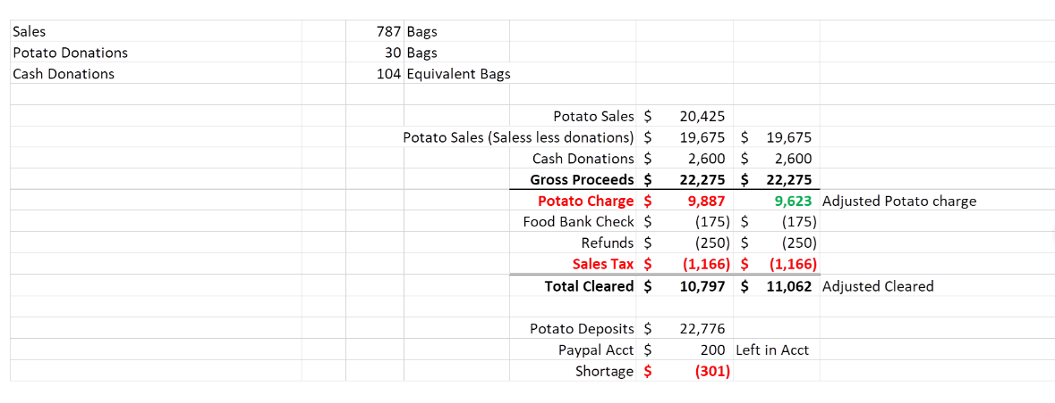

* 1. Haunted Hospital review (Oct. 22) – 300 paying customers (probably max that we can handle), set up and clean up all smooth. The kids raised $1400 for either the anatomage table or Be The Match – readdress in December
  2. Outreach subcommittee – SKAGGS foundation was recommended by the mayor to check as a possibility, Optum has turned us down. Blue Cross and ICOM pending.
  3. Curriculum review – no new updates at this time
  4. Jacket embroidery – Garry will contact Brook about format needed

1. New Business
   1. Holiday Bazaar (Nov.19) – funds from vendor table sales go to cost share for things such as bussing, other state costs. Request for Boosters to purchase decorations (Amazon list totaling approx. $350). Unanimous consent to approve $200. Brook and Malissa will work with Mrs. Kerns and buy some things locally.
   2. HOSA Booster money coming in on-line clarification – no $ coming in for Boosters through the office
2. Future Dates/Events/meetings
   1. Next Meeting: December 6, 2022 at 6:30pm. Location: MMACHS
   2. February 4, 2023 regionals at Timberline
3. Adjournment 7:34pm